

**The City School**

North Nazimabad Boys Campus

Reinforcement worksheet (Chemistry)

Class:10 & 11

Topic : Stoichiometry and mole concept

**Teacher: Zubaida Aslam Class: 10 & 11 Subject:Chemistry Date: 22nd Oct.2015**

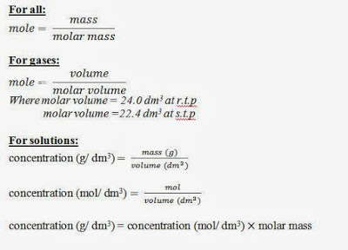

1: 2.8g of iron reactedcompletely with chlorine according to following equation

2Fe + 3Cl2  2 FeCl3

What mass of iron chloride is formed?

2: what volume of hydrogen is formed at room temperature and pressure when 6g of magnesium reacts with exess sulfuric acid?

Mg + H2SO4  MgSO4 + H2

3: 0.5 mol of a hydrated salt contains 63g of water.

1. How many grams of water of crystallization contained in 1 mol of salt?
2. How many moles of water are in this salt?

4: 2.38g of tin was converted to 3.02g of tin oxide. What is the formula of the compound?

5: Deduce the molecular formula of a compound with empirical formula CH2O and molecular mass 180.

6: calculate the percentage by mass of water in hydrated MgSO4.7H2O

7: A hydrocarbon contains 82.8% of carbon. Determine the empirical formula of this compound.

8: 50g of N2 and 10g of H2 are mixed to produce NH3. Calculate mass of NH3 formed and identify the limiting reactant in the production of NH3.

N2 + 3 H2 2NH3

9: calculate the concentration of NaOH in the solution prepared by dissolving 4g in 250cm3of water.

10: How many moles are there in 100cm3 0f 0.5 molar HCl solution.